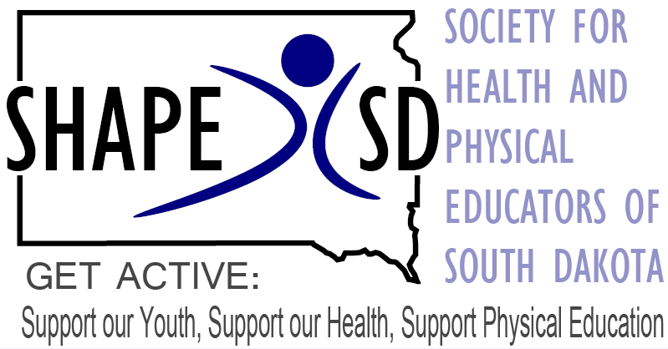

Strategic Plan 2020-2021
The Society for Health And Physical Educators of South Dakota is a group of professionals collaborating to promote healthy and active lifestyles for all South Dakotans.

Mission: Our Mission is to provide professional development opportunities for our members and to be advocates for our profession.

Vision: Get Active: Support our Youth, Support our Health, Support Physical Education

Purpose: The purpose of this strategic plan is to ensure that this Association will remain relevant to health and physical educators in South Dakota.

Strategic Partners: Our strategic partners include the SD Department of Education, SANFORD fit, SBOR Institutions of Higher Education, Central District SHAPE America and SHAPE America.
Strategic Goals: Strategic Goals will insure the continued relevance and vibrancy of this Association.
1. Provide quality professional development opportunities.
2. Increase and continue to develop our advocacy efforts.
3. Recruit and retain dedicated professionals into our membership rolls.

1. Provide quality professional development opportunities.
a) Continue to offer an annual convention of the highest quality and relevant topics for health educators, physical educators, and future professionals. This can best be measured with satisfaction surveys. The people responsible for the success of the convention are the members of the convention planning committee which includes all our Board members.
b) Provide adequate training and mentoring for both new and experienced Board members. This can be accomplished at our annual convention as well as the first regularly scheduled board meeting. This is easily measured, and the progress should be recorded in the minutes of each Board meeting.
2. Increase and continue to develop our advocacy efforts.
a) Continue to fund at least one Board member to represent SHAPE SD at The Speak Out Day, and a second Board member attending when funds allow.
b) Facilitate on-site visits to health education classrooms and gymnasium for elected officials. This requires our members to understand the value of a “home field advantage” when advocating for our profession. A measurable success indicator would be to have at least 50% of all Board members reach out and invite a state senator or representative to visit a health education classroom or gymnasium each school year. A second indicator would be to have each of our Board members invite at least one local school board member into their classroom during the school year. These indicators should also be recorded in the minutes of each Board meeting, and in each Board members progress reports.
3. Recruit and retain dedicated professionals into our membership rolls.
a) The first indicator of success should be growth. We have set a goal of growing by 3% each year until 50% of all health and physical educators in South Dakota are members of SHAPE SD.
b) A weakness we have identified is when a new person joins our Association, we do little if anything to bring them on board and make them feel welcome. This is an area where we have a lot of room for improvement. The Board will continue to brainstorm and cultivate new members. In the past activities such as Board Member Bingo, Pre-Conventions Socials, $50 reduced registration fee for new attendees and Olympics have been utilized.
c) The actual recruiting of new member is best performed by other members. It is imperative that all our members can articulate the benefits of membership to their colleagues.

This SHAPE SD strategic plan should be reviewed and updated annually.

